
Morgan Fitzgerald Middle 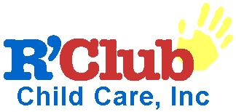
21st Century Community Learning Center
Extended Learning and Personal Enrichment Program

Enrolling Now
Program Hours
Monday - Friday
7:00 AM - 9:25 AM / 4:00 PM – 6:00 PM
Students must stay till 5:45 pm

We will be offering:
Tutoring
Homework Assistance
Enrichment in the Arts, Sciences, Technology & Sports
Positive Peer Relations Skills
Community and Family Involvement Projects

This is a FREE program open to all students of Morgan Fitzgerald Middle School, limited spots available.

An enrollment packet must be completed and approved by the R’Club staff for your child to attend

Please call 727-547-7046 for additional information.

